Hello Codestone Solutions,

We analysed the issue and found that the profit center NKCPR set up is invalid for company OEUS (Oxford Economics USA Inc.) on the contract ID 47798.

To post the source documents you will further have to change the Business configuration Product Category of Company and try reposting the contract as a solution.

Steps – In Business Configuration –> Profit center Derivation -> Profit Center Derivation by Product Category for Sales -> Product Category.

The product AMS_NKC_OE on the contract 47798 is linked to product category “902 - OE Africa Subscription Services”. This product category is then linked to profit center NKCPR for all companies. This is not the right profit center for company OEUS. I suggest removing the 2 rows with profit center derivations for this product category. The application will then derive the correct profit center based on the organization structure for the company.

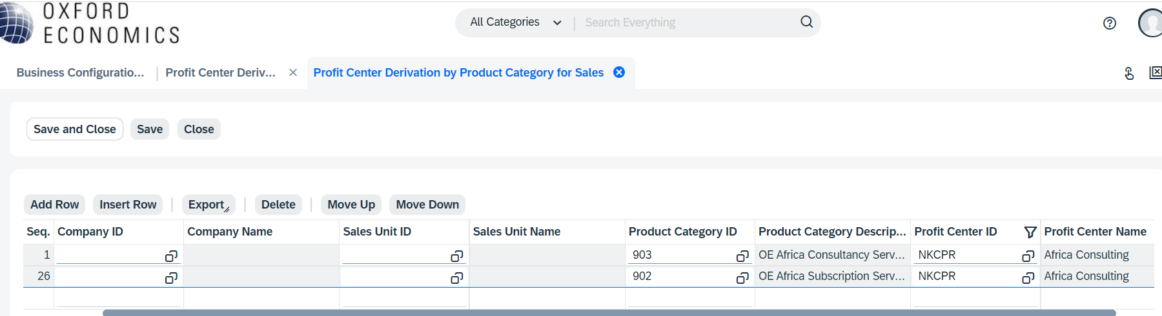

After changing the Business configuration for Product category of company you can try reposting the contract.

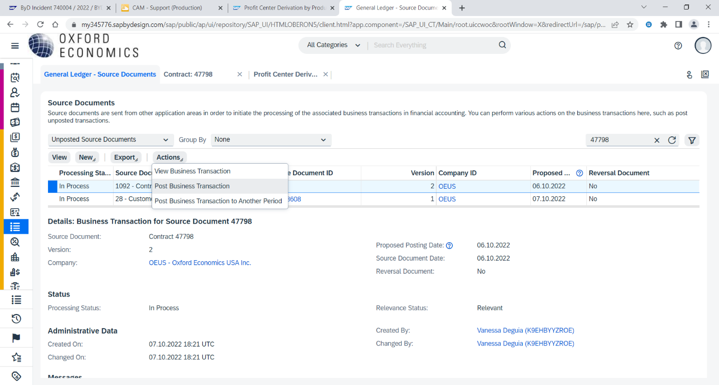Steps – General ledger –> Source documents –> Give Document ID -> Actions –> Post Business transaction –> View all -> Repost

Do let us know if you need any further assistance on this.

Thank you.

Regards,

Shruti G.